A000-Pac-Poly-HI-Hi-Kohala-Menehune face-Vesicular lava-1200 CE

SHAPE \* MERGEFORMAT 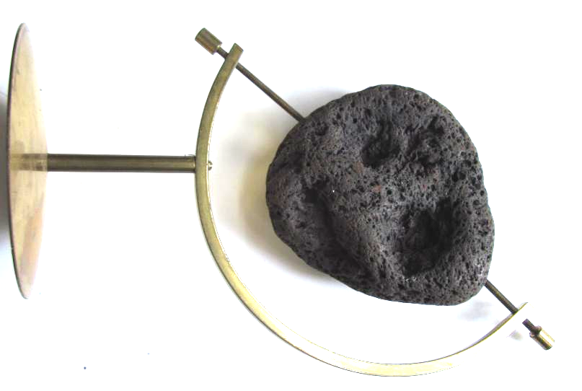

Pac-Poly-HI-Hi-Kohala-Menehune face-Vesicular lava-1200 CE

Case No.: 13

**Accession No.**

**Formal Label:** Pac-Poly-HI-Hi-Kohala-Menehune face-Vesicular lava-1200 CE

**Display Description:** This menehune face was found in Kohala on the island of Hawai'i. It dates to the first settlement of the Island possibly to the earliest period 0-700 CE. Note that the surface has been smoothened by ceremonial use and shows great patina. Extremely rare.

**LC Classification:**

**Date or Time Horizon:**

**Geographical Area:**

**Map:**

**GPS coordinates:**

**Cultural Affiliation:**

**Media:**

**Dimensions:**

**Weight:**

**Condition:**

**Provenance:**

**Discussion:**

**References:**